BARLETTA CARGO BIKE IDENTIFICATION
CURRENT AS AT JANUARY 2019

Generation 1 – 3

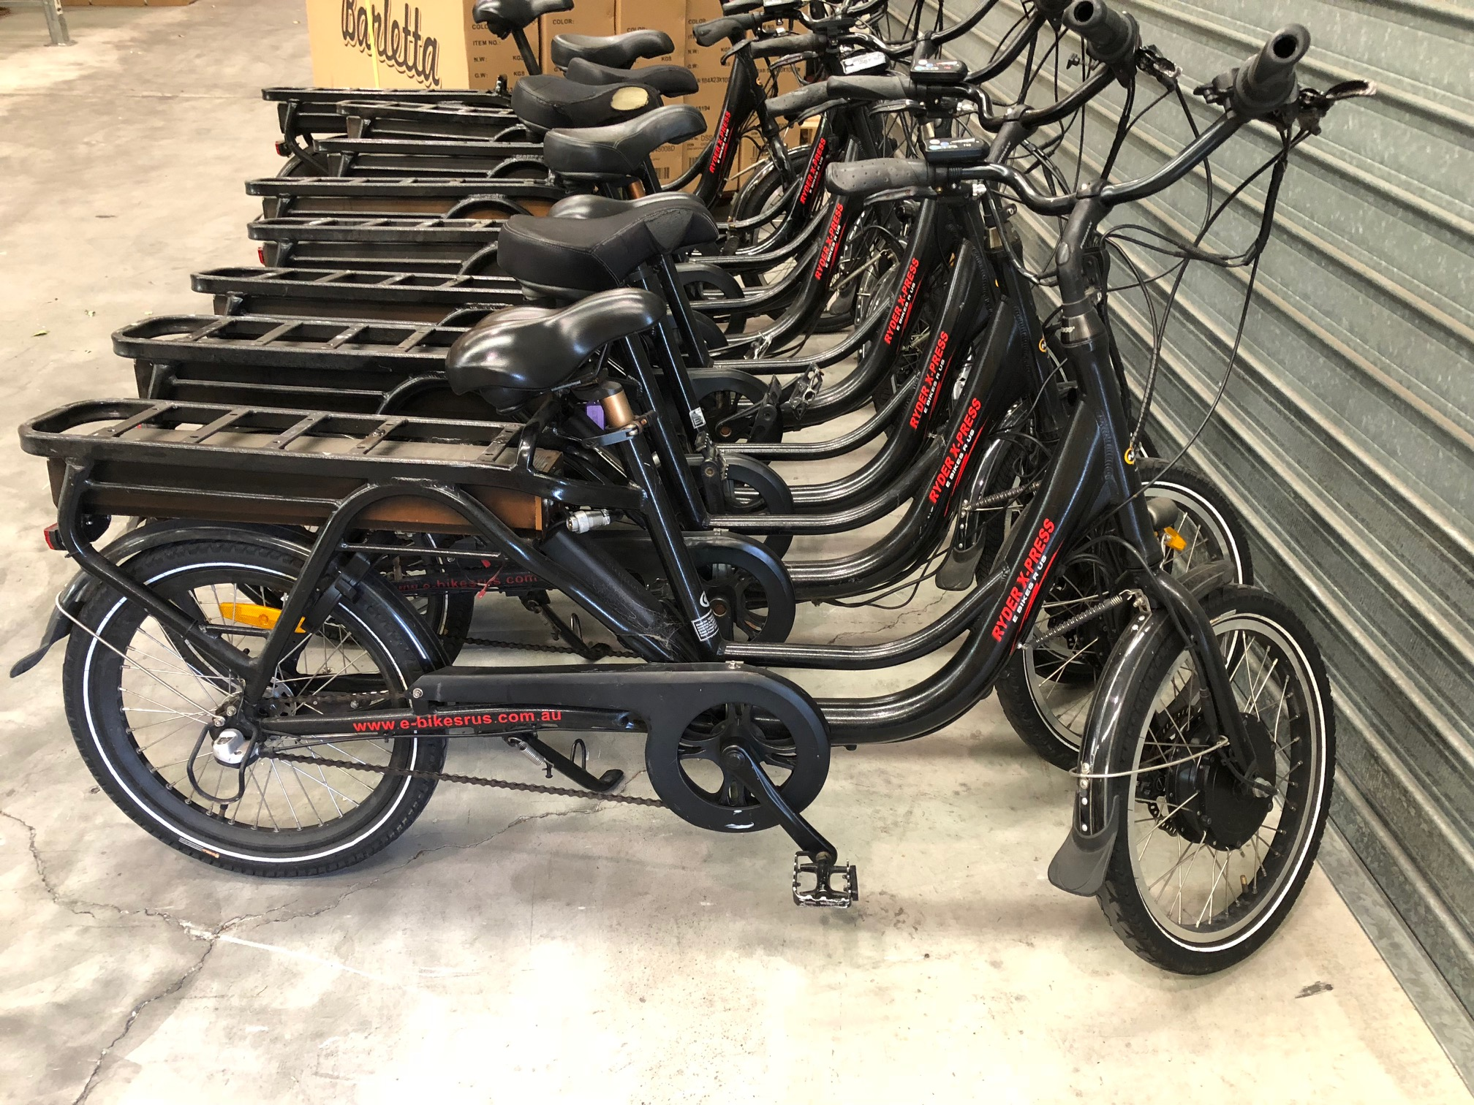

- Black frame
- 20” wheels
- Bafang front wheel drive 48V
- Front disc brake with motor cut out lever / Rear roller brake
- Battery under rear carrier
- Shimano 3 speed internal hub
- Quill type handlebar stem
Generation 4 – the same bike as in the above photo but with rear disc brakes

- Black frame
- 20” wheels
- Bafang front wheel drive 48V
- Front and rear disc brakes with motor cut out lever
- Battery under rear carrier
- Shimano 3 speed internal hub
- Quill type handlebar stem

Generation 5

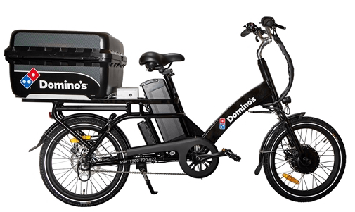

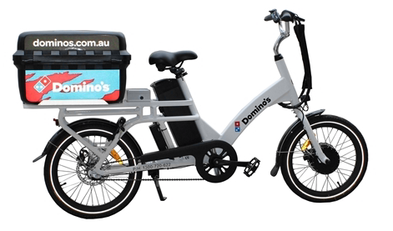

- Black or white frame
- 20” wheels
- Bafang SW.02 motor front wheel drive 48V
- Front and rear hydraulic disc brakes with motor cut out levers
- Battery behind seat tube
- Shimano Silent Clutch 3 speed internal hub
- Quill type handlebar stem

Generation 6

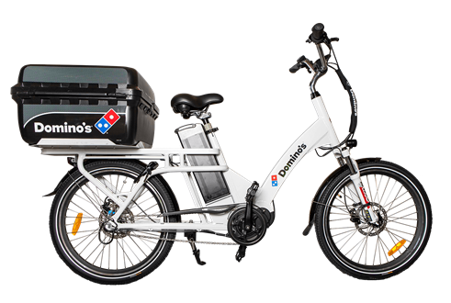

- White frame
- 24” wheels
- Bafang mid drive 48V
- Front and rear hydraulic disc brakes (no cut outs)
- Battery behind seat tube
- Shimano 3 speed internal hub
- Quill type handlebar stem
Generation 7
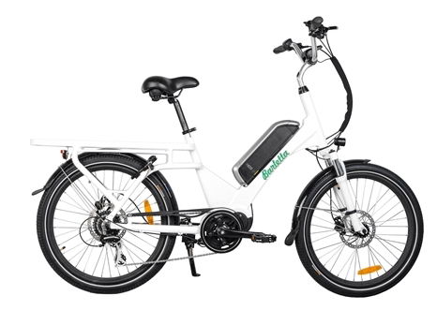
- White frame
- 24” wheels
- Bafang mid drive 48V
- Front and rear hydraulic disc brakes
- Battery on frame down tube
- Shimano 7 or 8 speed cassette derailleur gears
- Quill type handlebar stem
Generation 8

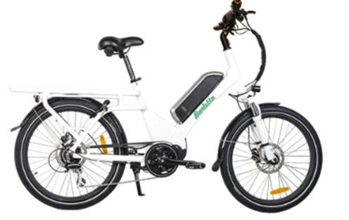

- White frame with single or dual downtube
- 24” wheels
- Bafang mid drive 48V
- Front and rear hydraulic disc brakes
- Battery on frame down tube
- Shimano 8 speed cassette derailleur gears
- Ahead type handlebar stem

Generation 9
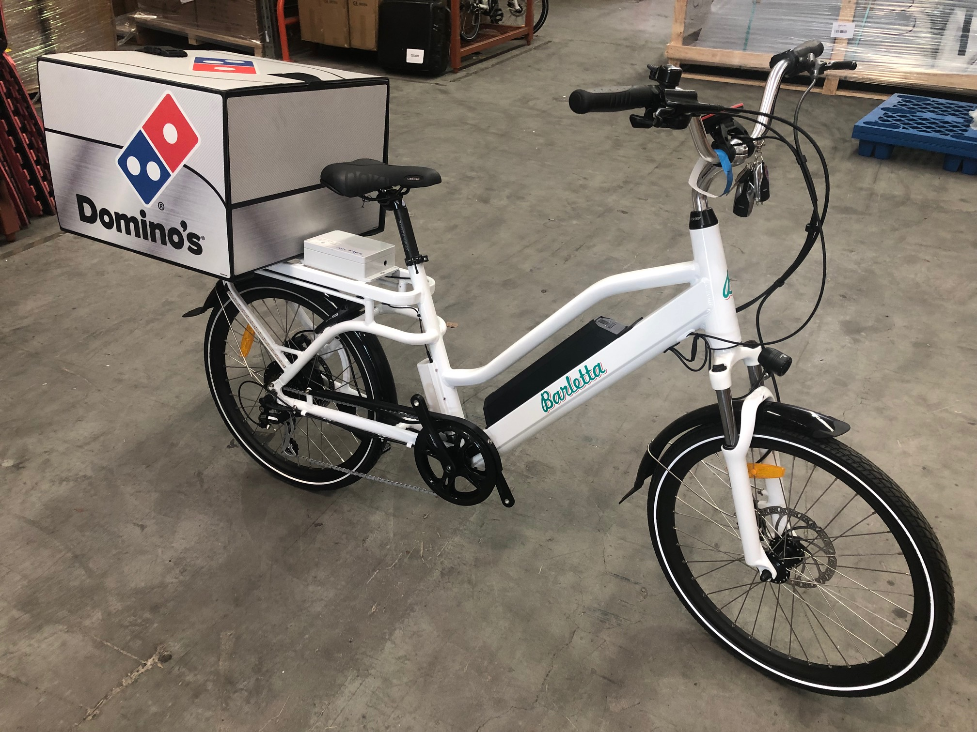

- Dual down tube frame with integrated battery
- 24” wheels
- Bafang rear hub drive 48V
- Front and rear hydraulic disc brakes
- 7 speed screw on derailleur gears
- Battery integrated in frame down tube
- Quill type handlebar stem
- Kingmeter display

Sumo

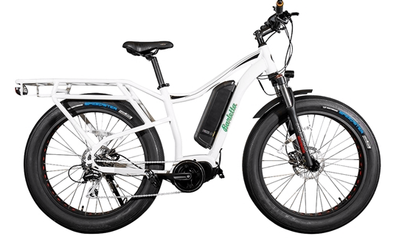

- White cruiser frame
- 26” fat wheels
- Bafang mid drive 48V
- Front and rear hydraulic disc brakes
- Battery on frame down tube
- Shimano 8 speed cassette derailleur gears
- Ahead type handlebar stem

Major changes between models highlighted

